IL-1b for the considered time points of 96,108 and 120 hours from onset are less than 10 for the DHF patients and a majority has shown even values near 0 and 1 pg/ml. Therefore, I’ve run the decision trees separately with IL1b and without IL-1b for all the time points.

I would like to know any possible reasons for this behaviour in IL-1b. Is it specific to this particular data set?

In the following figures, **y=1** refers to the **DHF** patients and **y=2** refers to the **DF** patients and **n** refers to the number of patients classified under that particular decision making.

**1. 96 hours with IL-1b**

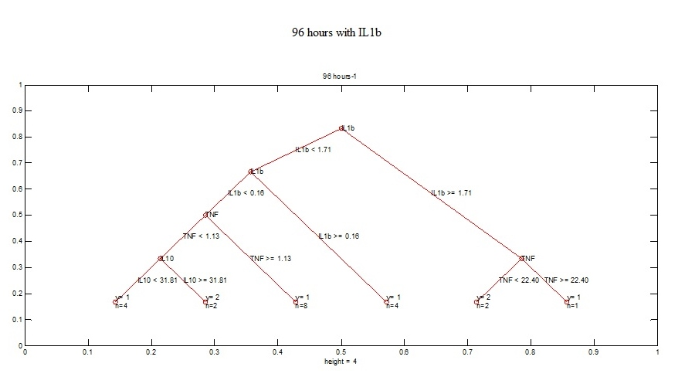

Categorization begins by looking at the IL-1b level.

If IL1b >=1.71 and TNF>=22.4, then the patient is categorized as DHF. However, there’s only 1 such DHF patient that falls to this categorization.

IF IL1b >=1.71 and TNF < 22.4, then the patient is categorized as DF.

Then, if IL-1b values are in the region [0.16, 1.71), the patient is categorized as DHF. Four patients are categorized in this way.

If IL1b <0.16 and TNF >= 1.13, then the patient is categorized as DHF. Eight DHF patients fall under this decision.

If IL1b <0.16 and TNF < 1.13, then to make a decision it looks into IL-10 values. In this case if IL-10 values are greater than 31.81, then two out of four DF patients are classified as DF. If IL-10<31.81, the decision is that the patient is DHF. Four DHF patients are classified in according to this decision.

The parameters PAF and S1P are not used in the decision making.

**2. 96 hours without IL-1b**

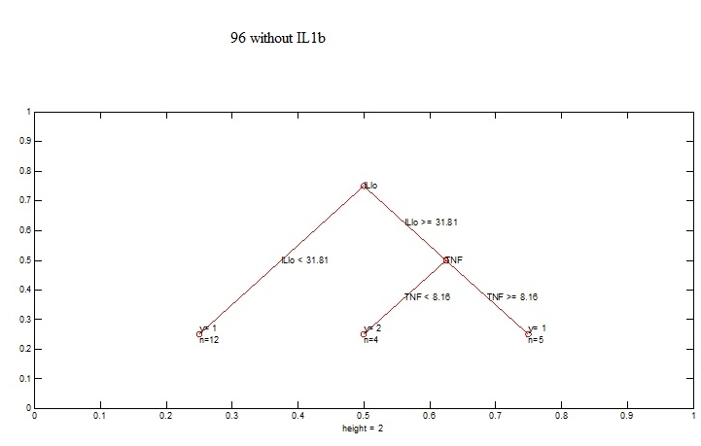

Categorization begins by looking at the IL-10 levels.

If IL-10 <31.81 then 12 DHF patients are directly classified as DHF. But, from what I understand, higher IL-10 values are associated with DHF patients. Discuss that But, in the data set 12 DHF patients have shown otherwise.

Then, if IL-10 >= 31.81 and TNF <8.16 patients can be classified as DF. All the four DF patients fall under this decision. So, according to this decision, TNF plays a vital role in classifying DF patients.

If IL-10 >= 31.81 and TNF >= 8.16, then those patients are DHF. Five patients are categorized under this decision.

Decision making is only based on two parameters, TNF and IL-10. Here also, PAF and S1P are not used.

**3. 108 hours with IL-1b**

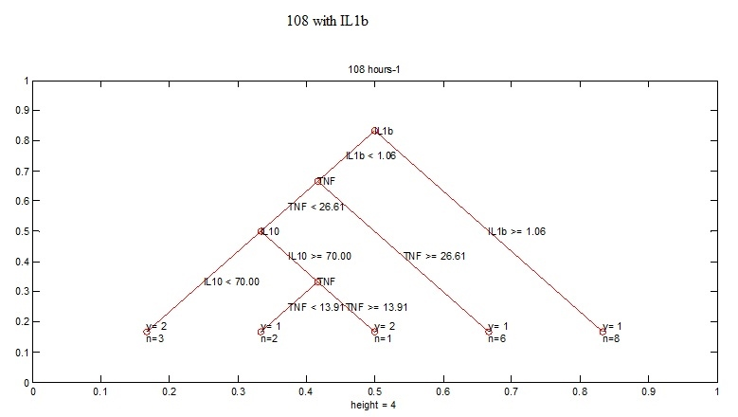

If IL-1b>= 1.06 directly, 8 DHF patients are classified.

If IL-1b< 1.06 and TNF >= 26.61, then it’s a DHF patient. Six DHF patients fall under this classification.

If IL-1b< 1.06 and TNF < 26.61, then the IL-10 values are looked at. If IL-10 is <70, then it’s a DF patient. Three DF patients are classified as such. If, IL-10 values are greater than 70 (IL-10>=70), then TNF is used to make the decision. If TNF >= 13.91, then it’s a DF patient. Otherwise it’s a DHF patient.

S1P and PAF are not considered in the decision process.

**4. 108 hours without IL-1b**

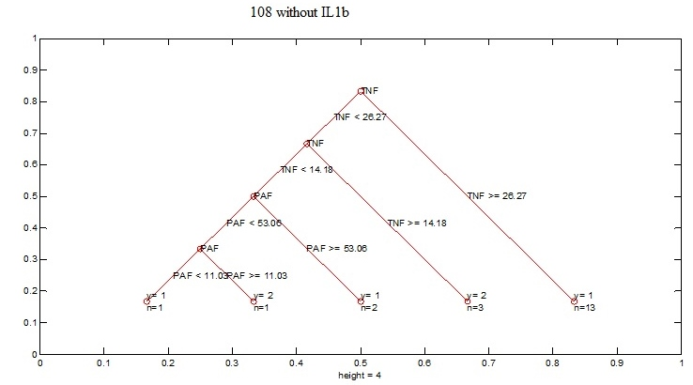

Decision making is started with TNF.

If TNF >=26.67, thirteen DHF patients are directly classified.

Then if TNF is in the region [14.18, 26.27) then it’s a DF patient. 3 are classified according to this decision.

If TNF <14.18 and PAF >= 53.06, then two DHF patients are classified as DHF.

If TNF < 14.18 and PAF < 53.06, then again the PAF values are looked at. If PAF is >=11.03, then it’s a DF patient. Otherwise, a DHF patient. However, there’s only one (out of 16) DHF patient that is classified in this way.

So, as there’s only one such DHF patient, and if this particular categorization is not that strong, by eliminating this particular DHF patient, the decisions can be simplified as,  
If TNF <14.18 and PAF >= 53.06, its DHF, and  
if TNF <14.18 and PAF < 53.06, then DF.

IL-10 and S1P are not used in classification.

**5. 120 hours without IL-1b and with IL-1b**

Here as the trees are too complexed, i.e. under each decision only a very few patients are classified, as the tree algorithm always categorizes each and every patient to the correct severity level (**n**, number categorized under each decision is small). As, the tree is too complexed, at 120 hours it is difficult to interpret decisions using the decision tree. This was true in both the cases with and without IL-1b.

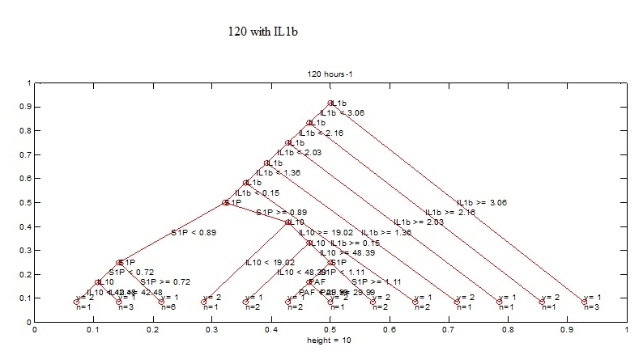

120 without IL-1b

